Question 1
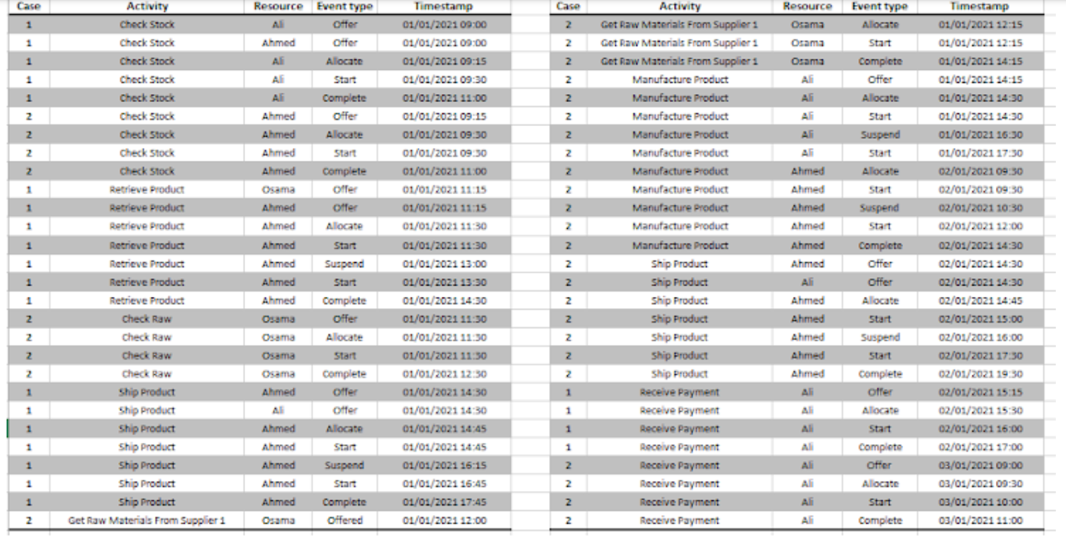

- Effective time (in hours) for resource “Ali” within activity “Manufacture Product” in case 2.
(16:30 – 14:30) + (9:30 1/1/2021 – 17:30 2/1/2021) = 18 hours

- Service time (in hours) for resource “Ali” within activity “Check Stock” in case 1.
11:00 – 9:15 = 1 hour and 45 minutes

- Choose the correct Sojourn time (in hours) and minutes for activity “Ship product” in case 2.
19:30 – 14:30 = 5 hours

Question 2
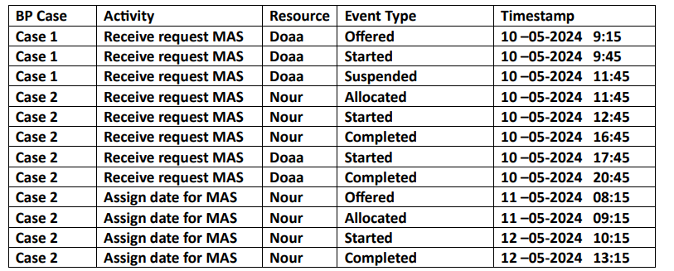

- Choose the correct waiting time (in hours) for within activity “Receive request MAS” in case 1.
9:45 – 9:15 = 30 minutes

- Choose the correct effective time (in hours) for resource “NOUR” within activity “Receive request MAS” in case 2.
16:45 – 12:45 = 4 hours

Question 3
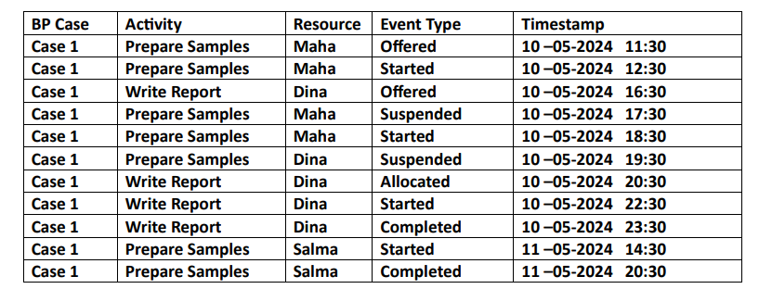

- Choose the correct Service time (in hours) and minutes for resource “Dina” within activity “Write Report” in case 1
23:30 – 20:30 = 3 hours

- Choose the correct Sojourn time (in hours) and minutes for activity “Prepare Samples” in case 1
20:30 11/5/2024 – 11:30 10/5/2024 = 12 hours + 30 minutes + 20 hours + 30 minutes = 33 hours +

Question 4
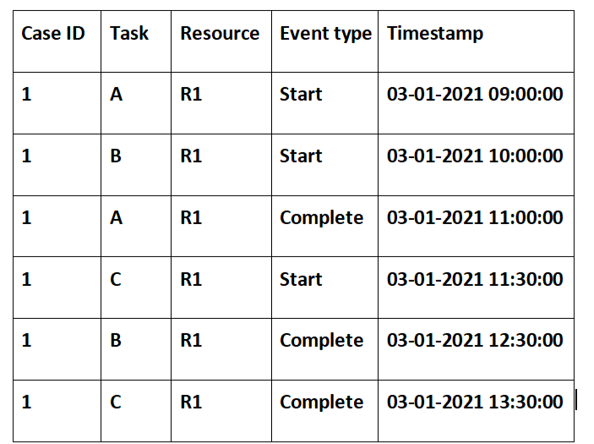
If there is an error in the log recording, then the most suitable resolution technique to resolve events overlapping is:
Defer Low priority item (DL).

Question 5
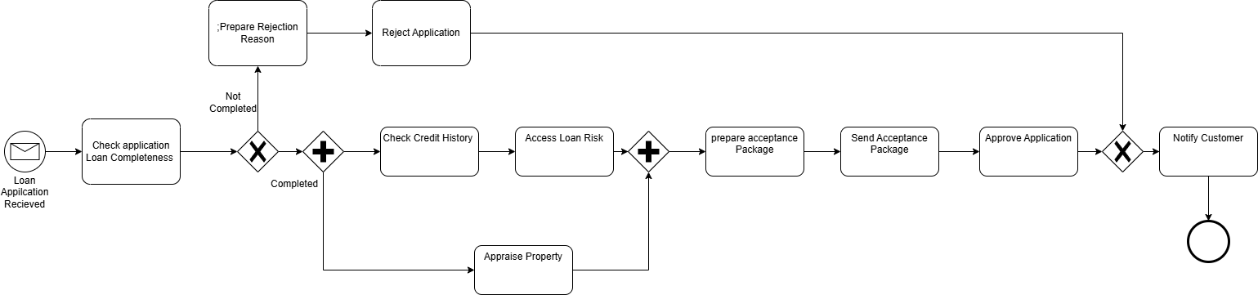
Given the following details:
- Check application Loan Completeness takes 5 hours
- Preparing Rejection Reason takes 2 hours
- Application rejection takes 1.5 hours
- Checking Credit History and Appraising Property takes 3 hours
- Accessing Loan Risk takes 0.5 hours
- preparing acceptance Package takes 1 day = 24 hours
- Sending Acceptance Package takes 2 hours
- Approving Application takes 1.5 hours
- Notifying the Customer takes 0.5 hour.
In Case 1, the Application is completed by the customer,
while in Case 2, the application is not completed and the bank needs more info from the customer.
Calculate the effective time per case. (Only Write The number of hours, For Example: 3)

- Effective time for Case 1 in hours
5 + ( MAX[ (3 + 0.5), 3 ] + 24 + 2 + 1.5) + 0.5 = 36.5 hours

- Effective time for Case 2 in hours
5 + 3.5 + 0.5 = 9 hours

